Lab 1 Report: Introduction to AI & Paradigms
Name: Rasikh Ali ID: 42365
1. Problem
A university wants to have a program that will help them in their scholarship selection process. The goal is to find those applications that are either incomplete or bad, to review them.
In this lab I am going to compare the following approaches to implement this task:
Approach A (rules-based): uses simple if-then statements that are easy to understand by everyone.
Approach B (probability-based): uses probability value and threshold.
The result "Review" just means that a human will need to review the application; it doesn't guarantee any scholarship for a student.
2. Assumptions
All numbers presented below are fictional and are used just as examples. These numbers don't reflect actual scholarship selection rules.
Minimum score: 70
Probability threshold: 0.70
Minimum GPA: 2.5
Probability values are completely fictional and no model is used here. This lab shows us the difference between the two approaches and it cannot be used to compare their accuracy because there are no correct answers to use.
3. What I've Created
lab1_compare.py: applies Approach A and B on four different cases and prints out their disagreements.
lab1_rules.py: an extended rule checker with four conditions and four checks.
The rule checker includes the following four conditions and all of them must be met to have the result of "Review":
1. Score is 70 or more (original)
2. Documents are complete (original)
3. Has letter: the student has a recommendation letter (new)
4. GPA is 2.5 or more (new)
When an application is rejected, the reason of this rejection is printed out. Limits are stored in the variables (MIN_SCORE and MIN_GPA)
4. Timeline of Events
1950 – The Turing Test
Event: Alan Turing proposed an idea for the imitation game, known as the Turing test.
Significance: It provided the concept of evaluating machine intelligence through conversation.
References: Turing, A. M. (1950). Computing Machinery and Intelligence. Mind, 59(236), 433-460.
1956 – Dartmouth Workshop
Event: An AI research program at Dartmouth college during the summer.
Significance: The term "Artificial intelligence" was coined during this period.
References: McCarthy, J., Minsky, M., Rochester, N., and Shannon, C. (1955). A Proposal for the Dartmouth Summer Research Project on Artificial Intelligence.
1974-1980 – First AI Winter
Event: There is less interest and funding towards AI research since many promises did not get fulfilled.
Significance: This was due to the 1973 Lighthill report. This is a good example of what happens when the promises are not fulfilled.
References: Lighthill, J. (1973). Artificial Intelligence: A General Survey. Science Research Council.
1980 – XCON Expert System
Event: The XCON (R1) expert system at Digital Equipment Corporation for configuring computer orders.
Significance: An excellent example of rule-based AI system. It shows the pros and cons of a rule-based approach to AI.
Reference: McDermott, J. (1982). R1: A rule-based configurer of computer systems. Artificial Intelligence, 19(1), 39-88.
2012 – AlexNet (new data and computing achievements)
Event: AlexNet, which uses GPU training and the big ImageNet database, wins an image recognition competition with a huge margin.
Importance: It proved that with larger data and faster computing & learning algorithms major breakthroughs could be achieved.
Reference: Krizhevsky, A., Sutskever, I., and Hinton, G. (2012). ImageNet Classification with Deep Convolutional Neural Networks. Advances in Neural Information Processing Systems 25.
2017 – The Transformer
Event: The Transformer architecture is proposed.
Importance: It allowed to build large-scale language models that laid foundations for current AI assistants.
Reference: Vaswani, A. et al. (2017). Attention Is All You Need. Advances in Neural Information Processing Systems 30.
5. Comparing the Two Methods (lab1_compare.py)
Step 1: My prediction (made before running)
complete_high -> Review | Review | no disagreement
complete_low -> Hold | Review | disagreement
incomplete_high -> Hold | Review | disagreement
boundary -> Review | Review | no disagreement
Step 2: Actual output
case | symbolic | threshold | disagreement
complete_high | Review | Review | False
complete_low | Hold | Review | True
incomplete_high | Hold | Review | True
boundary | Review | Review | False

The output matched my prediction.
Captured terminal output — lab1_compare.py
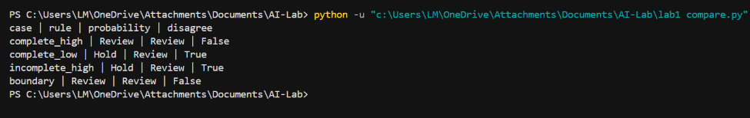
Step 3: Why they disagree
complete_low: The score is 68, which is below 70, so the rule says Hold. But the probability is 0.74, which is above 0.70, so the threshold says Review.
incomplete_high: The score is 91, but the documents are incomplete, so the rule says Hold. The threshold only looks at the probability (0.88) and cannot see the missing documents, so it says Review.
complete_high and boundary: Both methods agree.
Step 4: Boundary experiment
Score changed from 70 to 69 (probability stays 0.70): the rule changes to Hold, the threshold stays Review. The score condition caused the change.
Probability changed from 0.70 to 0.69 (score stays 70): the threshold changes to Hold, the rule stays Review. The probability cut-off caused the change.
This is a comparison of behavior only. A disagreement does not prove that one method is better, because we have no real correct answers.
6. Extended Rule Checker (lab1_rules.py)
Why I chose these four test cases
pass: everything is valid, to check that a good application passes.
no_letter: only the recommendation letter is missing, so it tests new condition 3 alone.
low_gpa: only the GPA is too low, so it tests new condition 4 alone.
boundary: score exactly 70 and GPA exactly 2.5, to check that the limit values are accepted.
Output
Test : pass
Input : score = 85 | docs_complete = True | has_letter = True | gpa = 3.4
Expected : Review
Actual : Review
Reason : all conditions met
Result : PASS

Test : no_letter
Input : score = 85 | docs_complete = True | has_letter = False | gpa = 3.4
Expected : Hold
Actual : Hold
Reason : no recommendation letter
Result : PASS

Test : low_gpa
Input : score = 85 | docs_complete = True | has_letter = True | gpa = 2.0
Expected : Hold
Actual : Hold
Reason : gpa too low
Result : PASS

Test : boundary
Input : score = 70 | docs_complete = True | has_letter = True | gpa = 2.5
Expected : Review
Actual : Review
Reason : all conditions met
Result : PASS

All four tests passed. Every Hold result comes with a clear reason.
Captured terminal output — lab1_rules.py
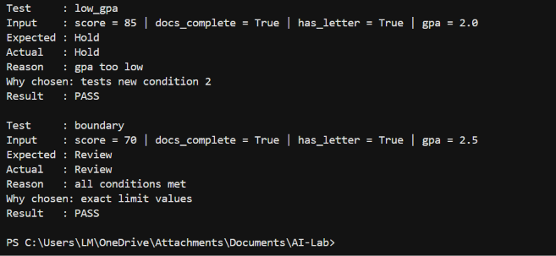
7. Conversation Test vs Real Intelligence
What a conversation test (Turing Test) observes: whether a machine's replies sound like a human's replies.
What it does not prove: that the system follows the rules, understands the task, or is correct every time. A system can sound confident and still be wrong.
Example of fluent but wrong reasoning: An assistant is given the case incomplete_high (score 91, documents incomplete). It says, "This is a strong application with a score of 91, so it should go to review." The answer sounds good, but it breaks the rule that incomplete applications must be held. It missed the incomplete documents.
One extra test for reliable performance: Give the assistant a fixed set of test applications, including incomplete and boundary cases. Count how often its Review or Hold answer matches the documented rule, and check that it gives the right reason. This measures real task performance, not how convincing it sounds.
Historical support: Turing (1950) proposed the imitation game to avoid the unclear question "can machines think?". The AI winter (Lighthill, 1973) shows that impressive claims do not always become real ability.
8. Comparison and Limitations
Rule-based method, strength: clear and traceable. Every decision can be explained.
Rule-based method, limitation: brittle. It only handles cases the rules cover.
Probability method, strength: can find complex patterns in data.
Probability method, limitation: the number does not explain itself, and it depends on good data and good testing. In this lab it accepted an incomplete application.
Neither is best for everything. Rules are better for clear requirements, such as complete documents. Probabilities are better when patterns are too complex to write as rules. A good design can use both: check the hard rules first, then use the probability.
9. Failure / Edge Case Analysis
Input: score 91, documents incomplete, probability 0.88 (incomplete_high).
What happened: the rule checker said Hold. The probability threshold said Review.
Likely cause: the threshold uses only one number and has no information about missing documents.
Improvement: check document completeness first, so an incomplete application is always held. Apply the probability threshold only after that. A human should also review flagged cases.
10. Reflection
What did I learn today? Rule-based and probability-based methods can give different answers on the same application, because each one uses different information. Also, sounding convincing does not prove a system is correct.
How will I use this in a real AI system? I will use explicit rules for requirements that must always be followed, and I will test any learned model on real labeled data.
What failed or surprised me? A high probability (0.88) still flagged an incomplete application. Also, changing a value by one step (70 to 69) changed the decision.
What would I do differently next time? I would write the test cases before the code and try more edge cases, such as missing values.
11. Responsible Practice
The numbers in this lab are invented and must not be used for real decisions. Review is only a suggestion for a human reviewer. A real scholarship system would need validated data, a clear owner for the policy, checks for unfair treatment, and human review. I have kept a clear line between what the code shows (behavior on four invented cases) and what it cannot show (accuracy or intelligence). All facts in the timeline are cited, and no private data or passwords are included in my submission.
12. References
Turing, A. M. (1950). Computing Machinery and Intelligence. Mind, 59(236), 433-460.
McCarthy, J., Minsky, M., Rochester, N., & Shannon, C. (1955). A Proposal for the Dartmouth Summer Research Project on Artificial Intelligence.
Lighthill, J. (1973). Artificial Intelligence: A General Survey. Science Research Council.
McDermott, J. (1982). R1: A Rule-Based Configurer of Computer Systems. Artificial Intelligence, 19(1), 39-88.
Krizhevsky, A., Sutskever, I., & Hinton, G. (2012). ImageNet Classification with Deep Convolutional Neural Networks. Advances in Neural Information Processing Systems 25.
Vaswani, A. et al. (2017). Attention Is All You Need. Advances in Neural Information Processing Systems 30.

